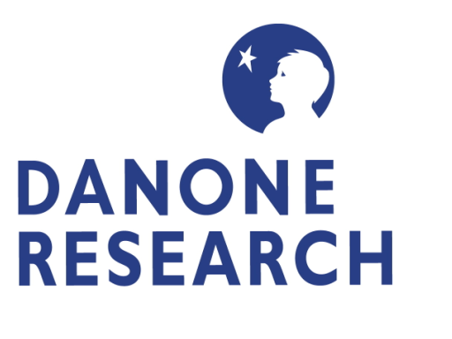
Press release
November 2007

DANONE RESEARCH is setting up a research network in Russia with some of the world's leading experts in microbiology, genetics and immunology, in a search for new pro-biotic lactic bacteria strains

The Groupe DANONE’s research arm has signed a three-year research agreement with Moscow State University's (MSU), Biology Department and the Institute of Immunological Engineering (IIE), in order to collect and study new strains of probiotic lactic bacteria and further expand its existing collection, which already contains more than 3000 strains sampled directly from different biological systems.

This agreement is part of the Groupe DANONE’s health innovation strategy, whose objective is to discover new health-benefits and market them through the creation of exclusive pro-biotic products.

With this partnership, DANONE's objective is to identify and study 250 new bacterial strains.

Russia is reputed for the richness and diversity of the micro-organisms contained in its traditional milk products. DANONE intends to focus its research on those regions whose population has traditionally enjoyed higher than average life-expectancy, a phenomenon which could be correlated to the presence in the intestinal flora of its inhabitants of certain lactic bacteria belonging to one of four species whose probiotic properties are already well documented: Streptococci, Lactococci, Lactobacilli and Bifidobacteria.

The bacteria will be collected directly from traditional milk products. Their study will be entrusted by MSU and IIE scientists. Different methods will be used, depending on the nature of the benefits being investigated.

Developed with the help of the International Science and Technology Center** (ISTC), based in Moscow, this partnership is part of the Groupe DANONE’s research strategy to encourage high-level scientific collaboration in key areas of expertise such as probiotics, which are at the heart of the Group's health food strategy.
Over the next three years, DANONE and their science teams in France will be working with research teams from MSU*** and IIE**** on a project that will be coordinated with the ISTC.

ISTC’s Executive Director, Norbert Jousten, welcomed DANONE’s engagement with the Russian research teams and their commitment to developing international science partnerships: “DANONE is one of ISTC’s newest Partners and have very quickly realized the benefits to their health innovation strategy in bringing their in-depth knowledge of the developing field of probiotics together with some of the foremost experts currently working in this area of important science research”.
At the end of the initial three-year project period, the bacterial strains of interest to DANONE will be made available to the group for exclusive use in its products, under terms to be determined in a subsequent contract.

Notes to Editors:

- DANONE RESEARCH
DANONE (RESEARCH) is the organization responsible for all DANONE R&D activities (800 employees). Its mission is to formulate the health benefits which the Groupe DANONE will claim for its products, and to produce scientific evidence for these benefits. It also studies the effects of alimentation on health and aims to continuously improve the nutritional profile of the group's products, everywhere in the world.
Present in 120 countries, the Groupe DANONE's turnover in 2006 was €14,07 billion.
2. ** The International Science and Technology Center (ISTC)
ISTC, based in Moscow, is an intergovernmental and non-profit organization that finds practical ways to redirect the creativity and intellectual capabilities of former weapons scientists in Russia and the Commonwealth of Independent States (CIS) towards meeting the technological and R&D demands of international business and industry. ISTC seeks to create long-term, sustainable employment opportunities for scientists and technical researchers within Russia and the CIS.

3. *** Moscow State University's Biology Department
Created in 1930 as a Department of the Moscow State University, the Biology Department comprises 28 sub-departments and 57 research laboratories. The Department has more than 1500 teachers and scientists and teaches more than 1200 undergraduate and PhD students. Research at the Microbiology Department has been focused on lactic acid bacteria screening for new bacteriocines, concerning bifido- and lactobacteria studies, its phylogeny and diversity, metabolism in gut and possible probiotic application, carbon metabolism (with collaboration with University of Freiburg, DE) and hydrogen production in anoxigenic phototrophic bacteria in photobioreactors including cells’ immobilization.

4. **** The Institute of Immunological Engineering
The Institute of Immunological Engineering (initially named as the “Institute of Immunology”) of the Joint Stock Company “Biopreparat” was founded in 1979 and has a remit to develop specific means of protection against dangerous diseases and to undertake research in the fields of immunology, microbiology, bioengineering and biotechnology. The Institute’s staff consists of 65 research officers, 36 are researchers, including 6 doctors of science (5 professors) and 21 Ph.Ds (candidates of science).

Media Contact:
Danone Research
Agnes Berthet – Head of communication – agnes.berthet@danone.com
Office: + 33 1 69 35 26 85 / Mobile: + 33 6 63 77 08 23

International Science and Technology Center (ISTC)
Steve Bourne - Communications Manager - Russian Federation - bourne@istc.ru
Office: (7-495) 982 3141 / Mobile: (7-895) 784 5190

in as much as they deliver a certain health benefit, if and when the product is consumed is sufficient quantity

