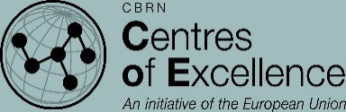
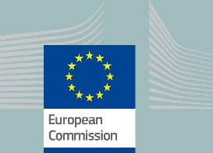
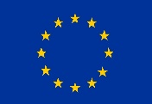

FACT SHEET

Project website:
http://cabichem.eu/index.php/en/

Project number:
IFS/2017/388-397

Project duration:
36 months
(November 2017 - November 2020)

Budget:
2.998.000 €

Source of funding:
European Commission,
Directorate-General for
International Cooperation and Development
(DG DEVCO),
Instrument contributing to Stability and Peace

Implementing agency:
Military Institute of Chemistry and Radiometry of Poland (MICHR)

Contact point: Mr. Maksymilian Stela
Mail: m.stela@wichir.waw.pl

Project contact information:

DEVCO project manager:
Tristan Simonart, (Tristan.simonart@ec.europa.eu)

The implementation of this project is managed by EC DG DEVCO

PROJECT-65: Strengthening chemical and biological waste management in Central Asia countries for improved security and safety risk mitigation

Geographical scope

Selected Central Asian countries in the framework of the CBRN Center of Excellence initiative: Mongolia, Kyrgyzstan, Uzbekistan, Tajikistan Pakistan, Afghanistan

Project 65 in brief

Three-year project started in January 2018

• Launching event in Dushanbe in March 2018
• 8 Work Packages addressed to Mongolia, Kyrgyzstan, Uzbekistan, Tajikistan Pakistan, Afghanistan
• Provision of awareness rising activities on chemical and biological waste management
• Implementation of a sustainable training system for lifelong learning
• Feasibility studies for deploying a possible remediation/ management of problematic sites
• Establishment of a regional technical consultation group

Project Abstract

The EU CBRN CoE Project 65 aims to strengthen existing chemical and biological waste management capabilities to ensure safe and secure collection, transportation, separation, processing, storage, disposal and inventory of hazardous CB waste originated by local industry (CB waste producers and CB waste management facilities), trade, agriculture, health care and past practices (dumping sites, historical industrial sites, former military bases etc.), as well as a consequence of emergency.
CABICHEM is funded by the European Union through its Instrument contributing to Stability and Peace and implemented to benefit the partner countries of the region of Central Asia, namely Afghanistan, the Kyrgyz Republic, Mongolia, Pakistan, and Uzbekistan.
Project 65 seeks to support national and regional bodies involved in the waste management main issues as well as to assist countries in reviewing and evaluating their legislative provisions on the matter. The project aims further to raise awareness of the issues associated with chemical and biological waste management as well as to provide training activities, including the train-the-trainer approach also based on a tailored e-learning instrument.
The project is coordinated by Military Institute of Chemistry and Radiometry – MICHR from Poland, and will be implemented by Fondazione FORMIT, the Istituto di Scienze e Tecnologie Molecolari – ISTM-CNR from Italy, the Military Institute of Hygiene & Epidemiology – MIHE from Poland, the Fondazione Alessandro Volta – FAV from Italy. Local senior experts with experience in CBRN domain will be supporting the activities in the partner countries.

Project Structure

- WP1 – Legislative, regulatory and procedural framework, including the waste management manual
- WP2 – Waste management bodies
- WP3 – Defining TORs for Equipping sites/facilities/labs
- WP4 – Awareness raising and training in sites/facilities/labs
- WP5 – Non-site/lab/facility hazardous waste
- WP6 – Preparation of sites remediation/management
- WP7 – Hazardous Wastes consultation group
- WP8 – Coordination with ongoing projects

