 

*SAC Meeting on*

***Emerging and Reemerging Infectious Diseases***

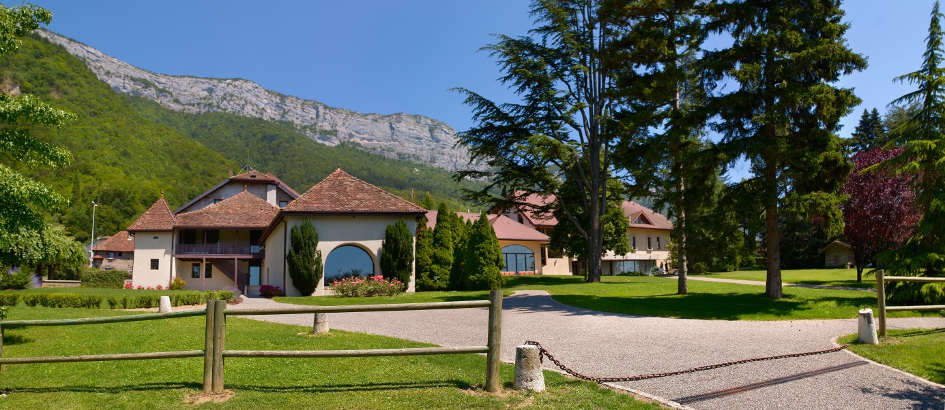

September 14 – 15, 2015

Fondation Mérieux

Les Pensières Conference Centre

The seminar **is intended for Scientists from National Laboratories and Institutes, Government Agencies, University Professors, and the Pharmaceutical Industry**. The main purpose is to foster scientists working in former USSR weapon laboratories to promote themselves and to help them secure interest with possibly financing for further joint peaceful research activities.

The presentations of scientific achievements will be divided into **three thematic sessions: (i) Emerging Infectious diseases: a continuous and global threat, (ii) Hepatitis B (HBV) and Hepatitis C (HCV) and (iii) Multidrug-resistant Tuberculosis.**

**Session 1. Emerging Infectious diseases: a continuous and global threat**

Scientists recognize the challenges societies face regarding these threatsthat largely come from animals. The solution for effective interventions requires collaborative efforts of multiple disciplines to address human-animal- ecosystem interface.

This session will provide an opportunity to discuss issues related to the risks factors for emergence of Filoviruses and Respiratory viruses.

**Session 2. Hepatitis B (HBV) and Hepatitis C (HCV)**

Chronic infections with hepatitis B virus (HBV) and hepatitis C virus (HCV) remain a major public health problem worldwide. The current research priorities for chronic hepatitis B and C are evolving differently: major achievements have been accomplished in the development of direct-acting antivirals for HCV whereas for HBV, despite the availability of an efficient vaccine, there are still more than 250 million chronic carriers worldwide.

The development of true combination therapy to "cure" HBV infection and issues related to access to treatment at the global level will be discussed.

**Session 3. Multidrug-resistant Tuberculosis (MDR-TB)**

Most people with tuberculosis can be cured by a strictly followed drug regimen. However, inappropriate or incorrect use of antimicrobial drugs, use of ineffective formulations of drugs, and premature treatment interruption can cause drug resistance.

In some countries, it is becoming increasingly difficult to treat MDR-TB. Treatment options are limited and expensive, recommended medicines are not always available, and patients experience many adverse effects from the drugs. In some cases even more severe drug-resistant tuberculosis may develop. Extensively drug-resistant TB, XDR-TB, is a form of multidrug-resistant tuberculosis with additional resistance to more anti-TB drugs that therefore responds to even fewer available medicines. It has been reported in 100 countries worldwide.

**40 scientists from several** **countries in Eastern Europe and Asia** will come from Afghanistan, Armenia, Azerbaijan, Georgia, Kazakhstan, Kyrgyzstan, Moldova, Mongolia, Pakistan, Tajikistan, Ukraine and Uzbekistan.

**The event approach** is to have two dedicated days. The official opening will be attended by Mr. Alain Mérieux, President of the Fondation Mérieux, Professor André Syrota, former president of French National Institute of Health and Medical Research, former president of French National Alliance for Life Sciences and Health and by Professor Jean-François Delfraissy, Director of the National Research Agency on AIDS and Viral Hepatitis (ANRS) and Director of the Institute of Microbiology and Infectious Diseases of French National Alliance for Life Sciences and Health.

**Program Monday 14th September 2015**

**9: 00 Welcome**

Mr. Alain Mérieux

Professor André Syrota

Graeme Frith

Vlada Pashynska

Professor Jean-François Delfraissy

**9:30 Session 1a. Emerging Infectious diseases: a continuous and global threat**

Chairs: Sylvie van der Werf and Xavier de Lamballerie

|  |  |
| --- | --- |
| 9:30 – 9:45 | ***Introduction by the chairs*** |
| 9:50 – 10:10 | **Daniel Bausch** - Department of Tropical Medicine Tulane University School of Public Health and Tropical Medicine – New Orleans, United States  *What will it take to be ready to detect and confront emerging infections?* |
| 10:10 – 10:30 | **Marie Paule Kieny** – WHO – Geneva, Switzerland  *R&D for potential vaccines, therapies and diagnostics in the time of Ebola* |
| 10:30 – 10:50 | **Farida Tishkova** - President of the Biosafety Association for Central Asia and the Caucasus – Tajikistan  *CCHF in Tajikistan* |
| 10:50 -11:10 | **Nataliya Vynograd** – Epidemiology department – Danylo Halytskji Lviv National Medical University – Lviv, Ukraine  *Challenge of natural foci viral EDP in Ukraine in modern time* |
| 11:10 – 11:30 | **Coffee break** |
| 11:30 – 11:50 | **Ali Mirazimi** - Karolinska Institute - Stockholm, Sweden  *Crimean Congo Hemorrhagic fever; An emerging viral hemorrhagic disease.* |
| 11:50 – 12:10 | **Chantal Reusken** - Erasmus - National Institute of Public Health and the Environment – Rotterdam, The Netherlands  *Middle-east Respiratory Syndrome virus, epidemiology and ecology* |
| 12:10 – 12:30 | **Nazir Jawad** - University of Veterinary and Animal Sciences -  Lahore, Pakistan  *Dengue Fever in Pakistan: Current Updates* |

**12:45 Lunch**

|  |  |
| --- | --- |
| 14:00 - 14:20 | **Peter Piot** - London School of Hygiene & Tropical Medicine – London, England  *Lessons from Ebola and AIDS* |
| 14:20 – 14:40 | **Hervé Raoul** – P4 laboratory – Inserm – Fondation Mérieux – Lyon, France  *The non human primate as a model for EBOLA virus infection* |
| 14:40 – 15:00 | **Kamoljon Mahmudov** - Veterinary Institute of the Tajik academy of agricultural sciences – Dushanbe city, Tajikistan  *Livestock brucellosis in the Republic of Tajikistan and the development of new struggle approaches* |
| 15:00 – 15:20 | **Sadraddin Gurbanov** - Republic Anti-Plague Station – Baku, Azerbaijan  *Some features of the spread of tularemia in Azerbaijan* |
| 15:20 - 15:40 | **Elmira Akmatova** - Kyrgyz Research Institute of Veterinary – Bishkek, Kyrgyzstan  *The epidemiological situation of natural focal animal diseases in Kyrgyzstan* |
| 15:40 – 16:00 | **Rysbek Nurgaziev** - Kyrgyz National Agrarian University – Bishkek, Kyrgyzstan  *The risk of spread transboundary animal infectious diseases* |
| 16-00 – 16:45 | **Coffee break** |

**16:45 Session 1b. Emerging Infectious diseases : human and social sciences and operational researches**

Chair: Benoit Miribel

|  |  |
| --- | --- |
| 16:45 – 17: 00 | **Introduction by the chair** |
| 17:00 – 17:20 | **Vinh-Kim Nguyen** - School of Public Health, Université de Montreal  *New anthropological insights on emerging infectious diseases* |
| 17: 20 – 17:40 | **Susan Shepherd** – ALliance for International Medical Action – Dakar, Senegal  *Integrated action among research institutions, medical NGOs and communities to meet the challenge of emerging infectious diseases - the example of ALIMA* |
| 17:40 – 18:00 | **Benoit Miribel** – Fondation Mérieux – Lyon, France  *Program GloPID-R* |

**18:15 Special Lecture**

**Bernard Pecoul -** DNDi - Drugs for Neglected Diseases initiative- Geneva – Switzerland

*Alternative approach to R&D for emerging infectious diseases*

**20:00 Dinner**

**Tuesday 15th September 2015**

**8:30 Session 2. Hepatitis B and Hepatitis C**

Chairs: Jean-François Delfraissy and Stefan Wiktor

|  |  |
| --- | --- |
| 8:30 – 8:40 | ***Introduction by the chairs*** |
| 8:45 – 9:00 | **Stefan Wiktor** : WHO – Geneva, Switzerland  *Viral hepatitis: Moving from control to elimination* |
| 9:00 – 9:15 | **Gayane Melik – Andreasyan** - The Research Institute of Epidemiology, Virology and Medical Parasitology - Yerevan, Armenia  *Current status of Hepatitis B and Hepatitis C in Armenia* |
| 9:15 – 9:30 | **Viktoriia Zadorozhna** – The L.V. Gramashevsky y Institute of Epidemiology and Infectious Diseases of NAMS of Ukraine – Kyiv, Ukraine  *Epidemiological features HBV infection in Ukraine* |
| 9:30 – 9:45 | **Fabrice Carrat** – Institut Pierre Louise d'Epidémiologie – Paris, France  *The ANRS CO22 HEPATHER Cohort: lessons and future prospects* |
| 9:45 – 10:10 | **Coffee break** |
| 10:15 – 10:30 | **Maia Butsahvili** - International School of Public Health – Tbilisi, Georgia  *Hepatitis C research in Georgia* |
| 10:30 – 10:45 | **Jessica Zucman-Rossi** – Inserm – Hôpital Saint-Louis, Paris, France  *Molecular profiling of hepatocellular carcinomas related to viral infections* |
| 10:45 – 11:00 | **Massimo Levrero** - Sapienza University of Roma - Dipartimento di Medicina Interna E Specialità Mediche – Roma, Italy  *Moving forward HBV cure* |
| 11:00 – 11:15 | **Ali Syed** - Nazarbayev University, Astana, Kazakhstan  *Promising helicase inhibitors for HCV treatment* |
| 11:15 – 11:30 | **Robert Thimme** - Universitätsklinikum Freiburg - Klinik für Innere Medizin II – Freiburg, Germany  *Perspectives of immunotherapy in HBV and HCV infection* |

**12:00 Lunch**

**13:30 pm Session 3. Multidrug-resistant Tuberculosis**

Chairs: François-Xavier Blanc and Philippe Glaziou

|  |  |
| --- | --- |
| 13:30 – 13:40 | ***Introduction by the chairs*** |
| 13:45 - 14:00 | **Philippe Glaziou** – WHO – Geneva, Switzerland  *Recent trends in drug-resistant TB* |
| 14:00 – 14:15 | **Anton Gerilovich** – Institute of experimental and clinical veterinary medicine- National Scientific Center – Kharkov, Ukraine  *Current epizootology of TB and its eradication in Ukraine* |
| 14:15 – 14:30 | **Luminita Gutu** – The Public institution State University of Medicine and Pharmacy "N.Testemitanu" – Chisinau, Moldova  *Epidemiology of MDR TB and HIV in Moldova* |
| 14:30 – 14:45 | **Almaz Aldashev** - Institute of Molecular Biology and Medicine – Bishkek, Kyrgyzstan  *Multidrug-Resistant strains of M. tuberculosis circulating in Kyrgyz Republic* |
| 14:45 – 15:00 | **Ekaterine Zangaladze** - National Center for Disease Control and Public Health – Tbilisi, Georgia  *Multidrug resistant TB in Georgia – a review* |
| 15:00 – 15:15 | **Emmanuelle Cambau** - Groupe Hospitalier Lariboisière-Fernand Widal – Paris, France  *Effective strategies for the diagnosis of multifdrug resistant tuberculosis* |
| 15:15 – 15:40 | **Coffee break** |
| 15:45 – 16:00 | **Jean Pierre Zellweger** - TB Competence Center - Swiss Lung Association – Berne, Switzerland  *Treatment options, controversies and outcome of MDR-TB* |
| 16:00 – 16:15 | **Piero Olliaro -** UNICEF/UNDP/World Bank/WHO Special Programme on Research & Training in Tropical Diseases – Geneva, Switzerland  *Strengthening capacities for implementation and operational research* |
| 16:15 – 16:30 | **Andrew J. Nunn** - MRC Clinical Trials Unit at UCL - Institute of Clinical Trials & Methodology – London, England  *MDR-TB RCTs: Bridging the evidence gap* |
| 16:30 – 16:45 | **Vincent Jarlier** – GH Pitié-Salpêtrière – Paris, France  *MDR-TB national consillium : principles, organization and results* |

**16:50 Closing remarks**

Professor André Syrota

Professor Jean-François Delfraissy

**Sponsors**









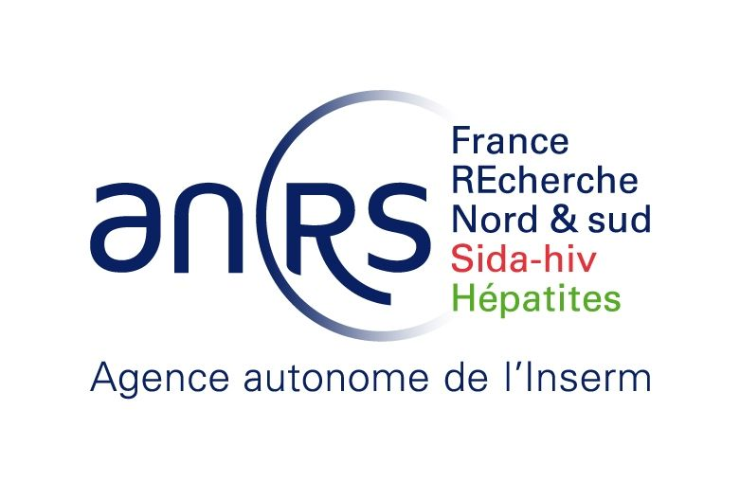

**Organizing committee**

**Prof. André Syrota**

**Dr. Masanori Araki**

**Prof. Jean-Pierre Contzen**

**Dr. Upendra Rohatgi**

**Prof. Jean-François Delfraissy**

**Dr Christine Guillard**

**David Cleave**

**Curtis Bjelajac**

**Graeme Frith**

**Dr Vlada Pashynska**

**Samal Asainova**

***With the collaboration of Dr Bernadette Murgue and Michel Zayet***

**Participants**

|  |  |  |  |  |
| --- | --- | --- | --- | --- |
| **SURNAME** | **First Name** | **COUNTRY** | **Institution** | **Mail** |
| AKMATOVA | Elmira | Kyrgyzstan | Kyrgyz Research Institute Of Veterinary | akmatova_elmira@yahoo.com, akmatova_elmira@mail.ru |
| ALDASHEV | Almaz | Kyrgyzstan | Institute Of Molecular Biology And Medicine | aldashev@gmail.com |
| ALI | Syed Hamid | Kazakhstan | Nazarbaev University | syed.ali@nu.edu.kz |
| ASSAINOVA | Samal | Kazakhstan | ISTC | asainova@istc.int |
| AVETISYAN | Lilit | Armenia | National CDC | avetisyan_lil@yahoo.com |
| BAASANDAVGA | Uyanga | Mongolia | National Center for zoonosis disease | Uyanga24@yahoo.com |
| BAUSCH | Daniel | Usa | Department Of Tropical Medicine Tulane University School Of Public Health And Tropical Medicine | bauschd@who.int |
| BLANC | François-Xavier | France | CHU Nantes | xavier.blanc@chu-nantes.fr |
| BURDUNIUC | Olga | Moldova | Highly Contagious Diseases of the National Center of Public Health | oburduniuc@rambler.ru |
| BUTSASHVILI | Maia | Georgia | Health Research Union | maiabutsashvili@gmail.com |
| CAMBAU | Emmanuelle | France | Groupe Hospitalier Lariboisière-Fernand Widal | emmanuelle.cambau@aphp.fr isabelle.dupriez@aphp.fr |
| CARRAT | Fabrice | France | Inserm | fabrice.carrat@free.fr |
| CLEAVE | David | Kazakhstan | ISTC | cleave@istc.int |
| CONTZEN | Jean-pierre | Belgium | SAC Member | [jeanpierre.contzen@skynet.be](mailto:jeanpierre.contzen@skynet.be) |
| DE LOMBALLERIE | Xavier | France | Inserm | xavier.de-lamballerie@univ-amu.fr |
| DELFRAISSY | Jean-françois | France | ITMO I3M - ANRS | [jf.delfraissy@inserm.fr](mailto:jf.delfraissy@inserm.fr) |
| DEMCHYSHYNA | Iryna | Ukraine | State institution “Ukrainian center of diseases control and monitoring MOH of Ukraine”, Vir Lab | irad@i.ua |
| DERYABIN | Pavel | Kazakhstan | Kazakh Scientific Center for Quarantine and Zoonotic Infections | pderyabin@gmail.com |
| DZHUMAGULOVA | Anara | Kyrgyzstan | Kyrgyz State Medical Academy | djumagulova_anara@ mail.ru |
| DZHURAEVA | Viktoriya | Tajikistan | Tajik Research Institute of Preventive |  |
| FRITH | Graeme | Kazakhstan | ISTC | graeme.frith@icloud.com, frith@istc.int |
| GERILOVICH | Anton | Ukraine | NSC "Institute of Experimental and Clinical veterinary Medicine" | antger2011@gmail.com |
| GLAZIOU | Philippe | Switzerland | WHO | GlaziouP@who.int |
| GUILLARD | Christine | France | Inserm | [christine.guillard@inserm.fr](mailto:christine.guillard@inserm.fr) |
| GURBANOV | Sadraddin | Azerbaijan | State Scientific Control Institute for Veterinary Preparations of Azerbaijan | sadr.gurbanov@yandex.com |
| GUTU | Luminita | Moldova | Public institution State University of Medicine and Pharmacy "N.Testemitanu" | lilammd@yahoo.com |
| JARLIER | Vincent | France | Groupe Hospitalier Pitié-Salpêtrière | vincent.jarlier@aphp.fr |
| KIENY | Marie-Paule | Switzerland | World Health Organization | ayatam@who.int - abiep@who.int |
| KOZHAMKULOV | Ulan | Kazakhstan | Nazarbaev University | ulan.kozhamkulov@nu.edu.kz, kzulan@gmail.com |
| LATIPOV | Renat | Uzbekistn | Research Institute of virology of Ministry of Health | renatlatip@gmail.com, renat.latipov@minzdrav.uz |
| LEVRERO | Massimo | Italia | Sapienza Universita' di Roma | massimo.levrero@gmail.com, |
| MAHMUDOV | Kamoljon | Tajikistan | Head of Virology Laboratory of the Tajik Research Institute of Preventive Medicine | mkamoljon@mail.ru, ipad.apple888@inbox.ru |
| MALANIA | Lile | Georgia | National Center for Disease Control and Public Health |  |
| MARUSHCHAK | Lyudmyla | Ukraine | State Scientific Research Institute of Laboratory Diagnostics and Veterinary and Sanitary Expertise | Maruschak@yandex.ru |
| MASANORI | Araki | Japan | SAC Member | [araki.masanori@jaea.go.jp](mailto:araki.masanori@jaea.go.jp) |
| MELIK ANDREASYAN | Gayane | Armenia | The Research Institute Of Epidemiology, Virology And Medical Parasitology | melikandreasyan@mail.ru |
| MIRAZINI | Ali | Sweden | Karolinska Institute | Ali.Mirazimi@ki.se |
| MIRIBEL | Benoit | France | Fondation Mérieux | benoit.miribel@fondation-merieux.org |
| NAZIR | Jawad | Pakistan | University Of Veterinary And Animal Sciences | jawad.nazir@uvas.edu.pk, jawadvet@gmail.com |
| NESTEROVA | Olena | Ukraine | Laboratory of Epidemiology of Plague  and Other Especially Dangerous Diseases of the Ukrainian Anti-Plague Institute | nesterova.olena@gmail.com |
| NGUYEN | Vinh-Kim | Canada | School of Public Health, Université de Montreal | vinhkim.nguyen@gmail.com |
| NUNN | Andrew | United Kingdom | MRC Clinical Trials Unit at UCL - Institute of Clinical Trials & Methodology | a.nunn@ucl.ac.uk |
| NURGAZIEV | Rysbek | Kyrgyzstan | Kyrgyz National Agrarian University Named After K.i. Skryabin | vetmed-kg@rambler.ru, rysbekn@mail.ru |
| OLLIARO | Piero | Switzerland | WHO | olliarop@who.int |
| PARONYAN | Lusine | Armenia | National Center For Disease Control And Prevention | lusineparonyan@yahoo.com |
| PASHYNSKA | Vlada | Ukraine | STCU | vlada.pashynska@stcu.int |
| PECOUL | Bernard | Switzerland | DNDi - Drugs for Neglected Diseases initiative | bpecoul@dnidi.org; bcrotty@dndi.org |
| PIOT | Peter | United Kingdom | London School Of Hygiene & Tropical Medicine | Peter.Piot@lshtm.ac.ukDonna.Bowers@lshtm.ac.uk |
| POPA | Sorin | Belgium | EU-DevCo | Sorin.POPA@ec.europa.eu |
| RAOUL | Hervé | France | P4 laboratory – Inserm – Fondation Mérieux | herve.raoul@inserm.fr |
| RASOOLY | Mohammad Hafiz | Afghanistan | Ministry of Public Health | dochafez @yahoo.com , influenza.surveillance@gmail.com |
| REUSKEN | Chantal | The Netherlands | Erasmus - National Institute Of Public Health And The Environment | c.reusken@erasmusmc.nl |
| ROHATGI | Kumar | USA | SAC Member | [rohatgi@bnl.gov](mailto:rohatgi@bnl.gov) |
| SANSYZBAYEV | Yerlan | Kazakhstan | Kazakh Scientific Center for Quarantine and Zoonotic Infections | esansyzbayev@kscqzd.kz, ysansybayev@list.ru |
| SHEPHERD | Susan | Switzerland | ALliance for International Medical Action – Dakar | [susan.shepherd@alima-ngo.org](mailto:susan.shepherd@alima-ngo.org) |
| SOOMRO | Munawar Hussain | Pakistan | Al-Nafees Medical College; Isra University-Islamabad Campus | munawar_soomro@hotmail.com |
| STEGNIY | Borys | Ukraine | NSC "Institute of Experimental and Clinical veterinary Medicine" (IECVM) | admin@vet.kharkov.ua |
| SYROTA | André | France | CEA | [andre.syrota@cea.fr](mailto:andre.syrota@cea.fr) |
| THIMME | Robert | Germany | Universitätsklinikum Freiburg - Klinik für Innere Medizin II | robert.thimme@uniklinik-freiburg.de katharina.bigot@uniklinik-freiburg.de |
| TISHKOVA | Farida | Tajikistan | Biosafety Association for Central Asia and the Caucasus; Afghanistan and Tajikistan Regional Biosafety Training Centre ;Virology Laboratory of the Tajik Research Institute of Preventive Medicine | ftishkova@gmail.com |
| TRAPAIDZE | Nino | Georgia | Cru/tmc | TRAPAIDZE@YAHOO.COM |
| TSERETELI | David | Georgia | National Center for Disease Control and Public Health | rabdato@yahoo.com, Dr.Tsereteli@gmail.com |
| VAN DER WERF | Sylvie | France | Institut Pasteur - Paris | sylvie.van-der-werf@pasteur.fr |
| VYNOGRAD | Nataliya | Ukraine | Danylo Halytskiy Lviv National Medical University | vynogradno@ukr.net |
| WIKTOR | Stefan | Switzerland | WHO | wiktors@who.int |
| ZADOROZHNA | Viktoriia | Ukraine | SI "The L.V.Gromashevsky Institute of Epidemiology and Infectious Diseases of NAMS of Ukraine | viz2010@ukr.net |
| ZANGALADZE | Ekaterine | Georgia | National Center for Disease Control and Public Health | molbio@ncdc.ge, zangaladze@yahoo.com |
| ZELLWEGER | Jean-pierre | Switzerland | TB Competence Center - Swiss Lung Association | zellwegerjp@swissonline.ch |
| ZUCMAN-ROSSI | Jessica | France | Inserm | [jessica.zucman-rossi@inserm.fr](mailto:jessica.zucman-rossi@inserm.fr) |