EU CBRN CoE Project 53 Booklet
Bio-safety and Bio-security Project in Central Asia
The following booklet was produced as part of the European Union Centres of Excellence (CoE) Initiative Project 53 “Strengthening the National Legal Framework and Provision of Specialized Training on Bio-Safety and Bio-Security in Central Asian Countries”.

Table of Contents

Foreword ……………………………………………………………………………………………………………………………………………3
Introduction ……………………………………………………………………………………………………………………………………….4
Regional achievements ……………………………………………………………………………………………………………………….5
Highlights in Afghanistan …………………………………………………………………………………………………………………….7
Highlights in Kazakhstan ……………………………………………………………………………………………………………………..8
Highlights in Kyrgyz Republic ………………………………………………………………………………………………………………9
Highlights in Mongolia ………………………………………………………………………………………………………………………10
Highlights in Pakistan ………………………………………………………………………………………………………………………..11
Highlights in Tajikistan ………………………………………………………………………………………………………………………12
Highlights in Uzbekistan ……………………………………………………………………………………………………………………13
Partner Countries’ Institutions …………………………………………………………………………………………………………..14
P53 Lead Implementer ……………………………………………………………………………………………………………………..15
P53 EU Team of Implementers …………………………………………………………………………………………………………16
EU CBRN CoE ……………………………………………………………………………………………………………………………………17

EU CBRN CoE Project 53
Bio-safety and Bio-security Project in Central Asia

Under the scope of the European Union Chemical Biological Radiological and Nuclear Risk Mitigation Centres of Excellence Initiative (EU CBRN CoE), Project 53 (P53) focuses on: enhancing local ownership by making local experts key part of the implementation team of the project, supporting collaboration and cooperation between various ministries, governmental agencies and institutions within each Partner Country, encouraging regional cooperation between the Partner Countries of P53, fostering international cooperation in the implementation of P53 by engaging with international organizations (such as the World Health Organization, Food and Agriculture Organization, The Organization for Security and Co-operation in Europe, World Organisation for Animal Health, Biological Weapons Convention implementation support unit, European Bio-Safety Association, and others), and finally, increasing long-term sustainability of the P53 outcomes, by aiming to incorporate the developed training programs formally into the educational system

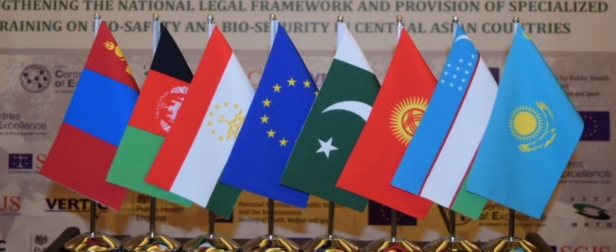
P53 is implemented in a close cooperation between National Teams of Experts (NTEs) of the Partner Countries, International Science and Technology Center (ISTC) and an EU Team of Experts (ToE). The ToE is a UK-led consortium (SCJS) of international legislative experts (VERTIC), and bio-safety and bio-security training experts (PHE, RIVM). Duration: Duration: 42 months (Dec 2015 – June 2019)
Budget: 6,521,540 €

The purpose of P53 is to strengthen the legal framework and to provide specialized training on bio-safety and bio-security in the Partner Countries of Central Asia
P53 Partner Countries: Islamic Republic of Afghanistan, Republic of Kazakhstan, Kyrgyz Republic, Mongolia, Islamic Republic of Pakistan, Republic of Tajikistan and Republic of Uzbekistan

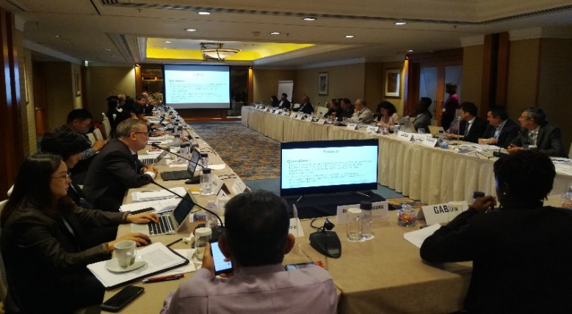
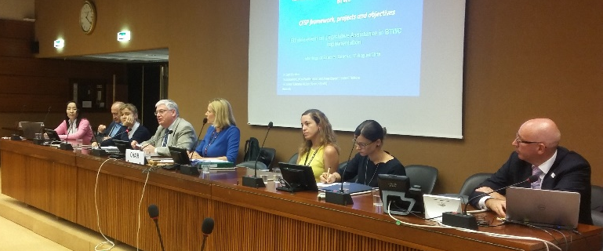
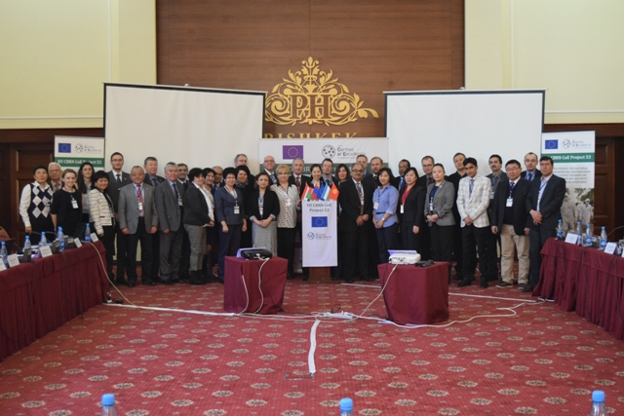
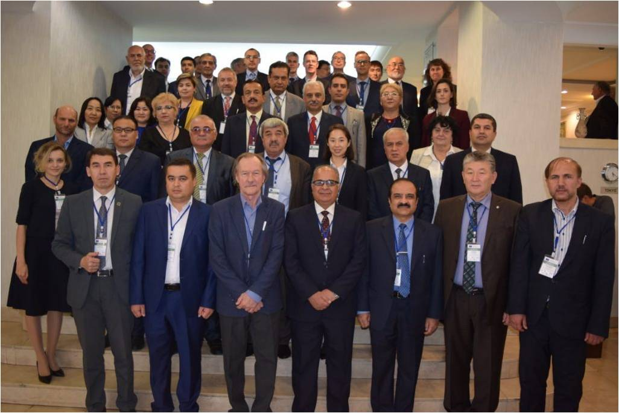
P53 co-organized side event at the BWC Meeting of Experts
P53 together with the EU co-organized a side event, titled “Strengthening National Implementation”, at the BWC Meeting of Experts on 13 August 2018, with participation from Mongolia, Tajikistan, EU Team of Experts and ISTC. Over the course of the Project P53 participated in 6 regional and international BWC meetings.

P53 Central Asia Region Achievements
Project 53 participated in WHO Technical Consultation
Experts from Kazakhstan, Mongolia and VERTIC represented EU CBRN CoE Project 53 in the Technical Consultation on National Cross-sectoral Collaboration between Security and Health Sectors organised by the World Health Organization (WHO) in Hong Kong, SAR China. The Technical Consultation facilitated sharing of experiences between countries to identify best practices and develop a framework for military and civilian health collaboration.

Second P53 Regional Meeting
Conducted in Tashkent on 2 – 3 November 2017 to discuss greater regional cooperation and with international programs on biosafety and biosecurity issues. Delegations from all Partner Countries participated in the meeting together with the EU Team of Experts, EU officials, UNICRI, ISTC and representatives of international organizations (OSCE, WHO, OiE, FAO, BACAC, US CDC and DTRA).

First P53 regional meeting
Conducted in Bishkek, 2-3 February 2017, to provide a platform to discuss regional aspects of P53 by experts from the participating countries, European Union, UNICRI, ISTC and the EU team of Experts.
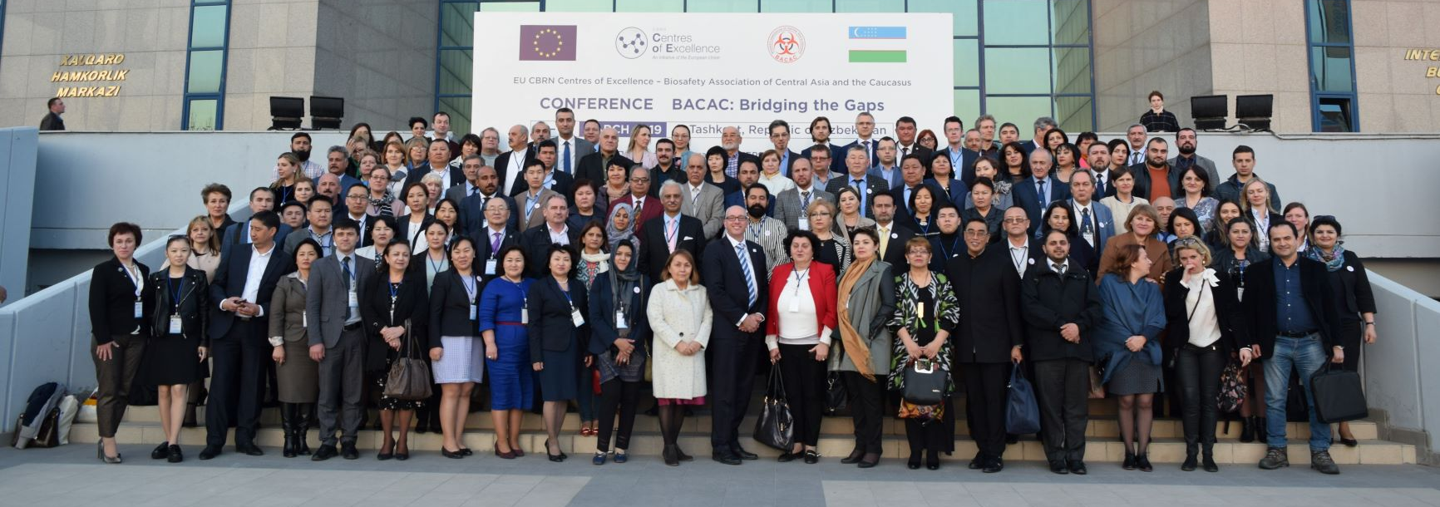
P53 Central Asia Region Achievements
Emergency Response Planning in Central Asia: Common Challenges and Opportunities for Cooperation
This report was published in September 2018. It identifies key requirements and best practices and highlights regional initiatives, common challenges and opportunities for cooperation in emergency response planning in Central Asia.

“P53 Experience on Biosafety & Biosecurity”
was presented at the 16th Medical Biodefense Conference, Munich, Germany by a team of Kazakh experts from EU CBRN CoE Project 53 last 28 to 31 October 2018. Prof. Andrey DMITROVSKIY provided the Project 53 accomplishments in a presentation and an abstract about EU CBRN CoE Project 53 was published in the proceedings of the Medical Biodefense Conference.
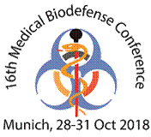
EU CBRN Centres of Excellence – Biosafety Association of Central Asia and the Caucasus Conference
The European Union Chemical, Biological, Radiological and Nuclear Risk-mitigating Centres of Excellence Initiative (EU CBRN CoE) and the Biosafety Association of Central Asia and the Caucasus (BACAC) conference “BACAC: Bridging the Gaps” was conducted 11-15 March 2019, in Tashkent, Uzbekistan. Over 170 participants took part in the meeting from Central Asia, the Caucasus, European Union, United States of America, and various international organization (WHO, OIE, IFBA, EBSA, UNICRI, UNOG, ISTC and STCU). The conference aimed at supporting cooperation and coordination at a regional and international level and to stimulate discussions on strengthening policies, capabilities and capacities to mitigate Biosafety and Biosecurity risks.

Project Highlights in Afghanistan

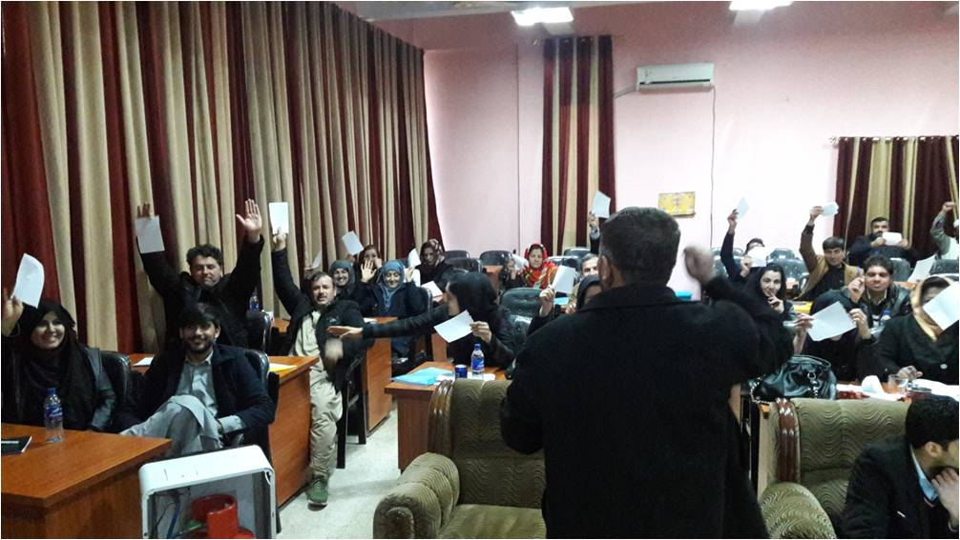
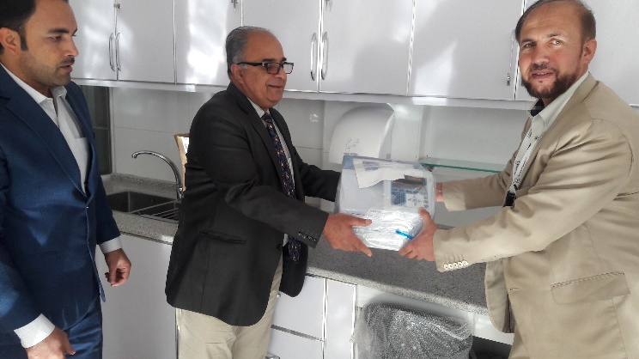
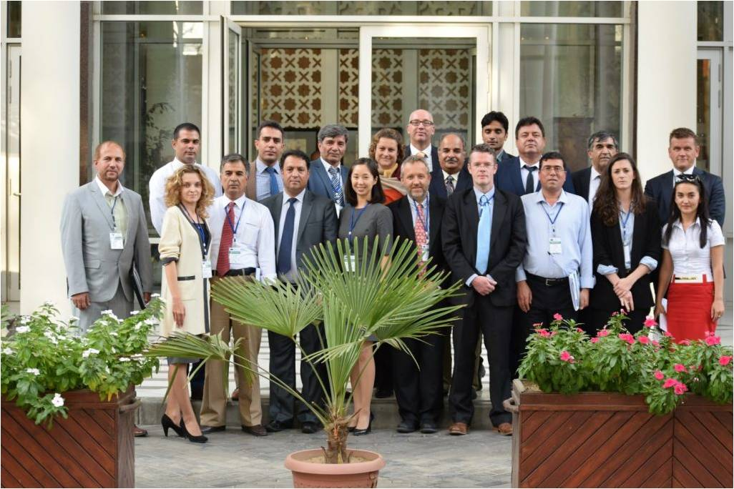
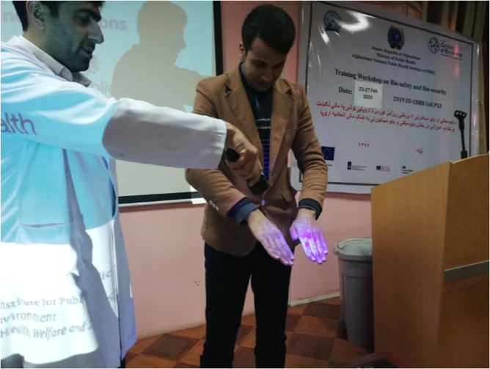
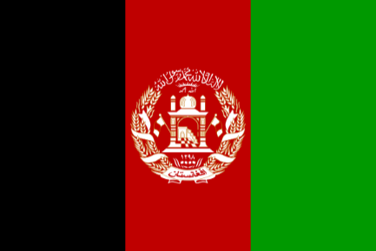
Legislative Recommendations
were formulated by the NTEs and EU ToE on the harmonization of national legislation of the P53 Partner Countries to the Biological Weapons Convention (BWC), International Health Regulations (IHR) and Codex Alimentarius (Codex)

197 experts and specialists trained in 9 workshops by the end of the project

Laboratory Equipment and materials were provided to the afghan institutions within the framework of Project 53, as well as, the training facility at the Afghan National Institute of Health was refurbished.
Train-the-Trainer workshop in Bio-safety/security was conducted for 10 trainers from Afghanistan

Afghan national Project 53 kick-off meeting was conducted on 26-27 September 2016
Project Highlights in Kazakhstan

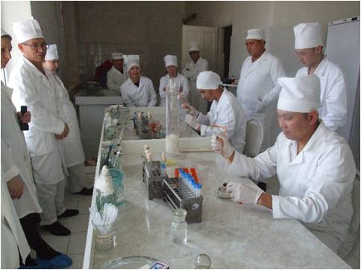
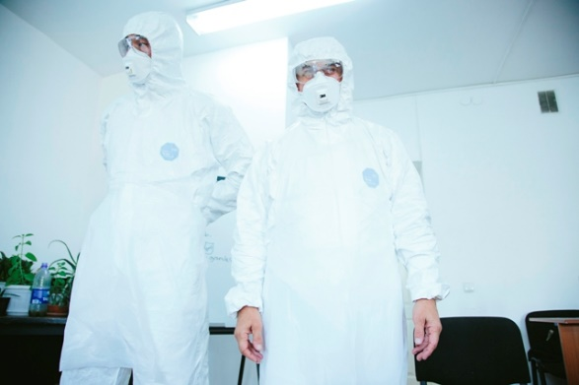
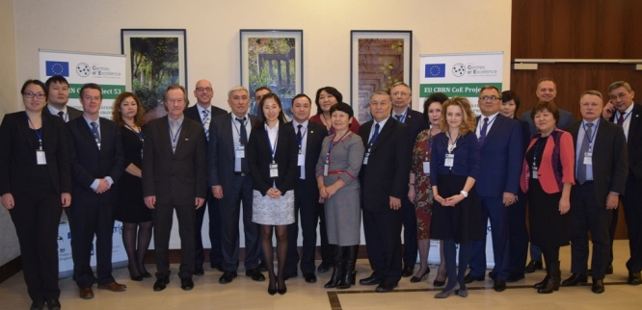
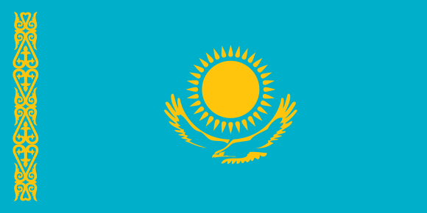
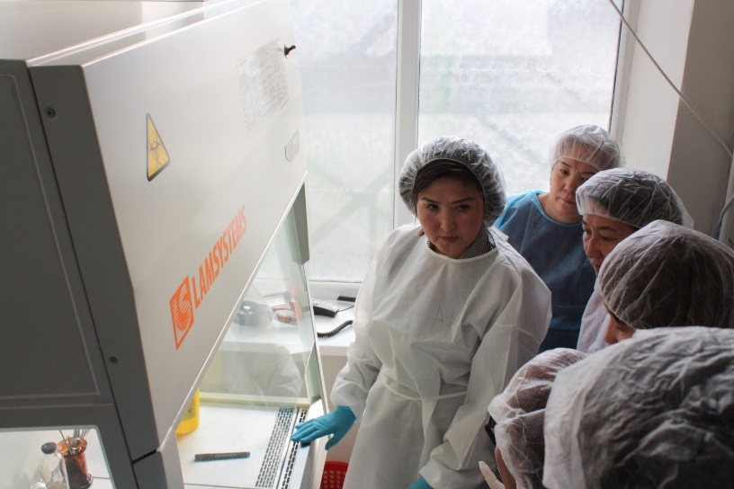
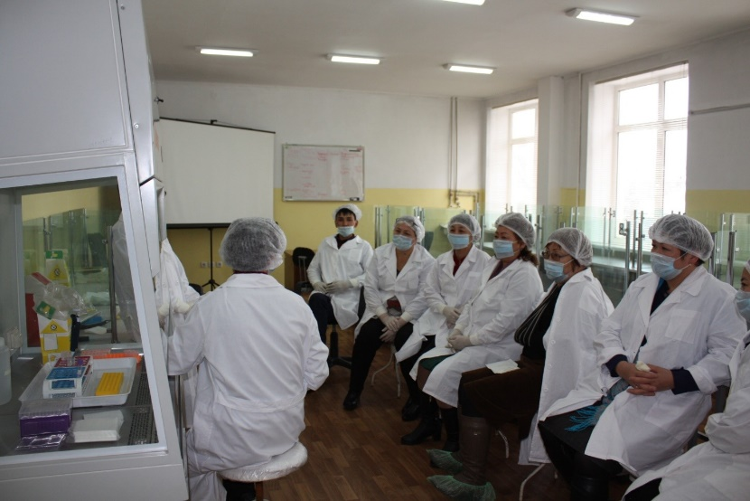
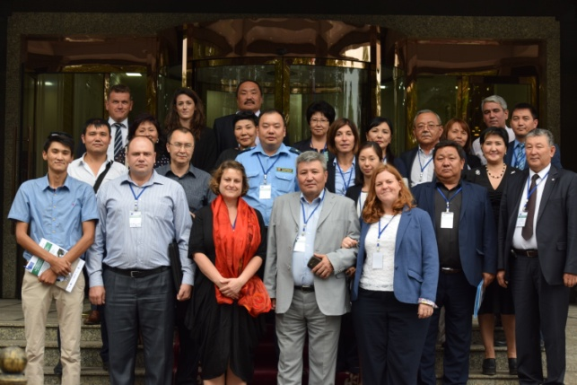
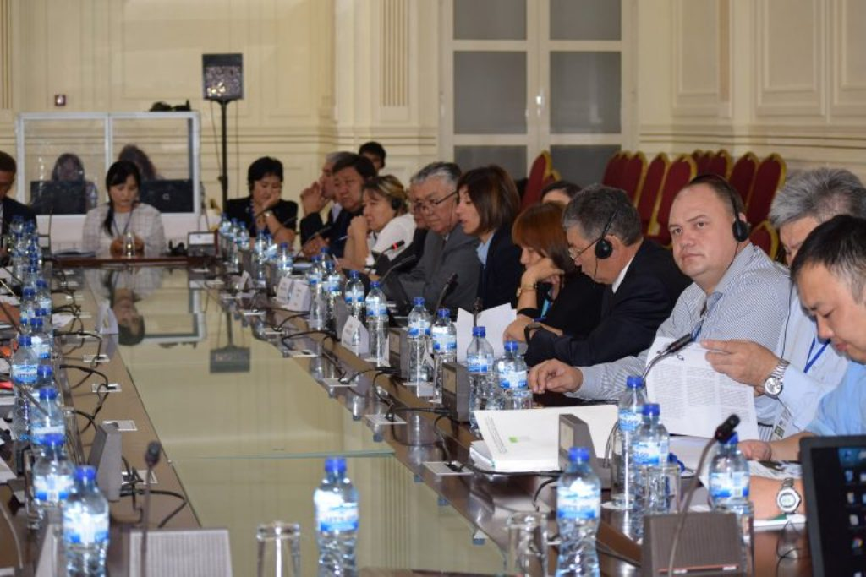
Legislative Recommendations
were formulated by the NTE and EU ToE on the harmonization of national legislation of the P53 Partner Countries to the Biological Weapons Convention (BWC), International Health Regulations (IHR) and Codex Alimentarius (Codex). Moreover, a draft Biosafety and Biosecurity law was developed.

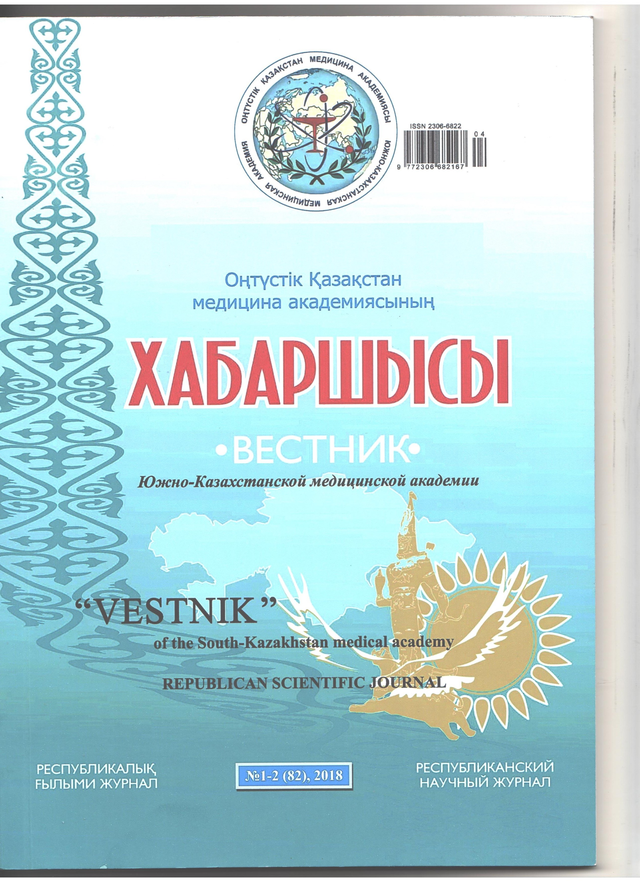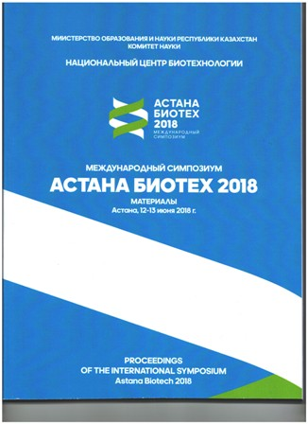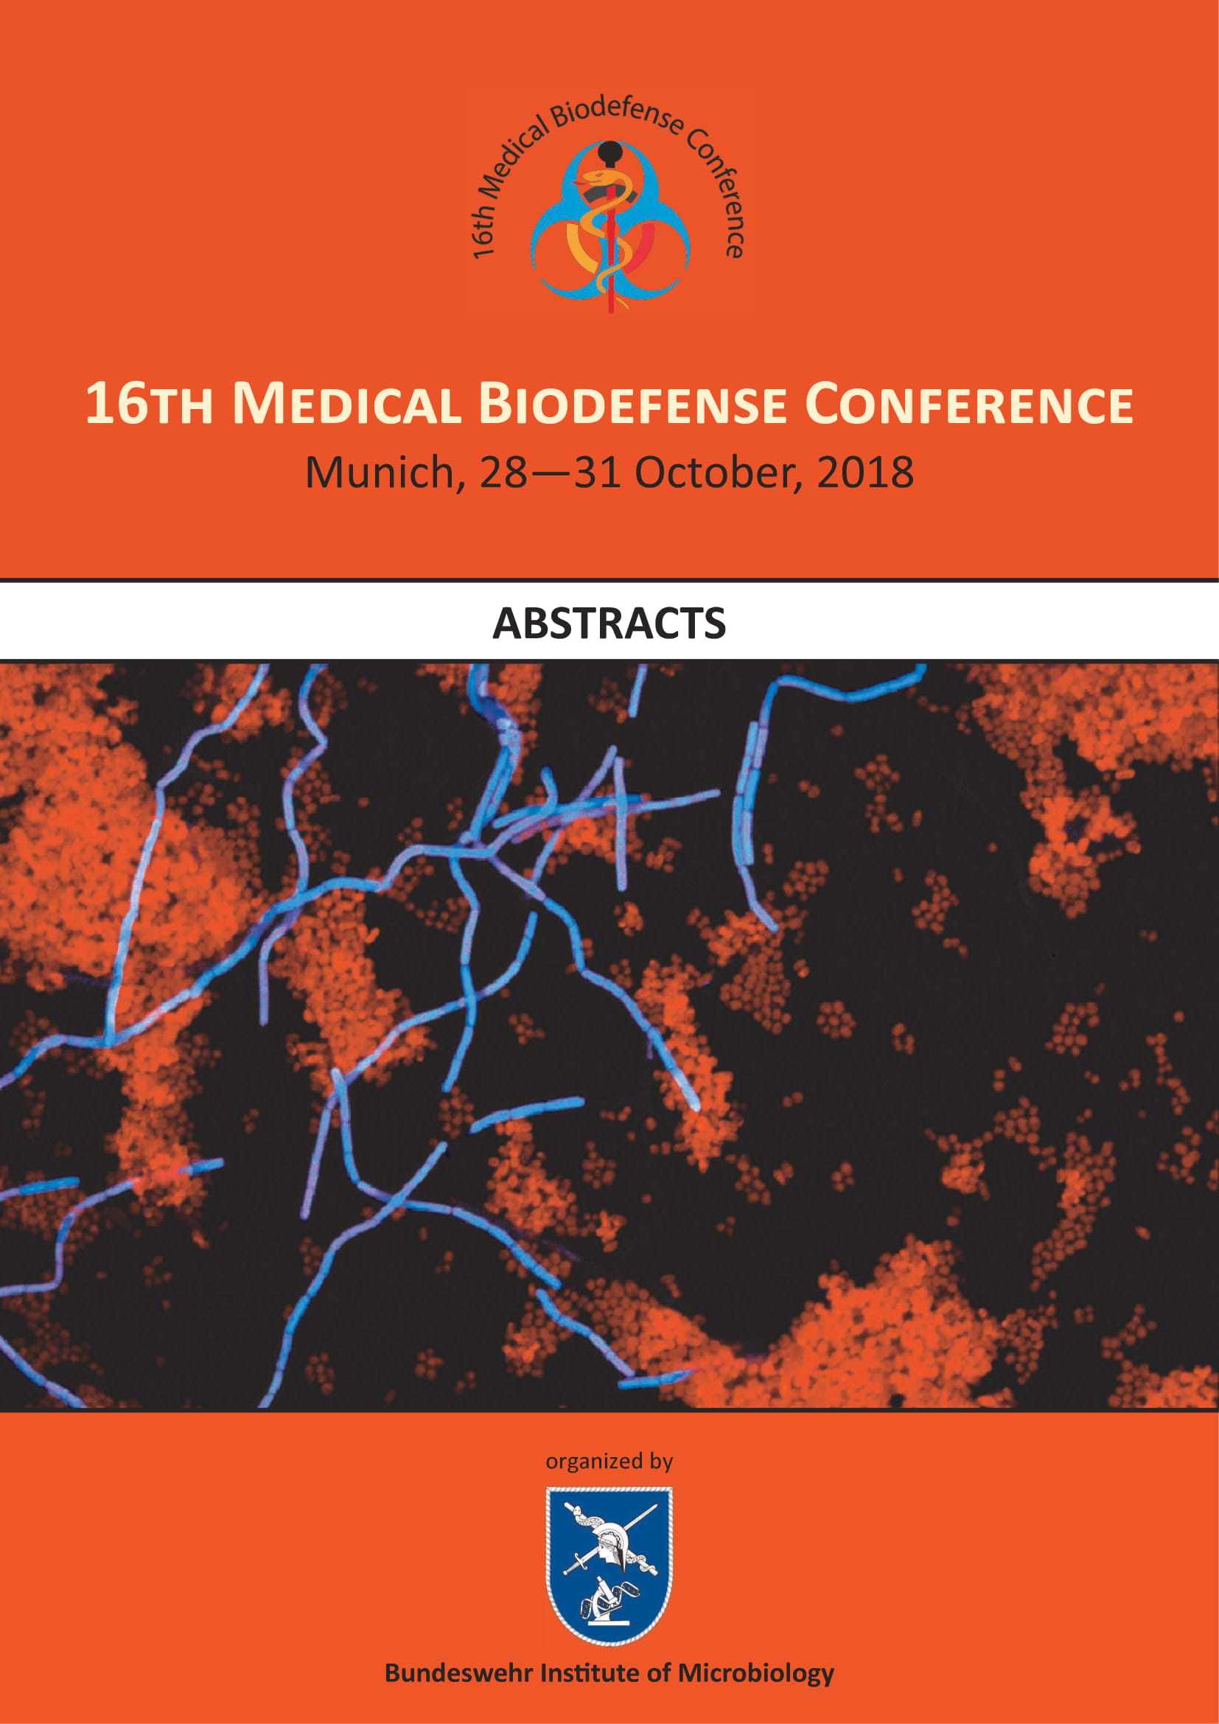
Three Scientific Publications about the project’s achievements in Kazakhstan posted in scientific magazines

810 experts and specialists trained in 22 workshops by the end of the project, including 2 Kazakh specialist that received international recognised certificates for Biosafety Cabinet Maintenance and Certification. Additionally, a sample isolation workshop was provided to Kyrgyz experts and equipment maintenance to Afghan experts.

Laboratory Equipment and materials were provided to the Kazakhstan institutions within the framework of Project 53
Train-the-Trainer workshop in Bio-safety/security was conducted for 14 trainers from Kazakhstan

Kazakhstan national Project 53 kick-off meeting 30 January 2017, Astana, Kazakhstan

Legislative Recommendations
were formulated by the NTE and EU ToE on the harmonization of national legislation of the P53 Partner Countries to the Biological Weapons Convention (BWC), International Health Regulations (IHR) and Codex Alimentarius (Codex). In addition, Kyrgyz experts are participating in WHO roundtable meetings on IHR implementation.

Project Highlights in Kyrgyz Republic

171 experts and specialists trained in 10 workshops by the end of the project

Laboratory Equipment and materials were provided to the Kyrgyz institutions within the framework of Project 53
Train-the-Trainer workshop in Bio-safety/security was conducted for 12 trainers from Kyrgyz Republic

Kyrgyz Republic national Project 53 kick-off meeting 19 – 20 September 2016, Bishkek
Project Highlights in Mongolia

Train-the-Trainer workshop in Bio-safety/security was conducted for 12 trainers from Mongolia

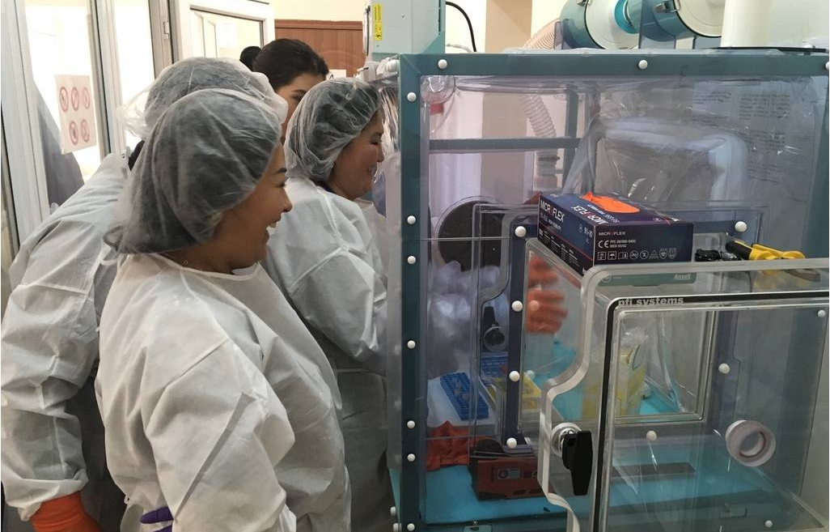
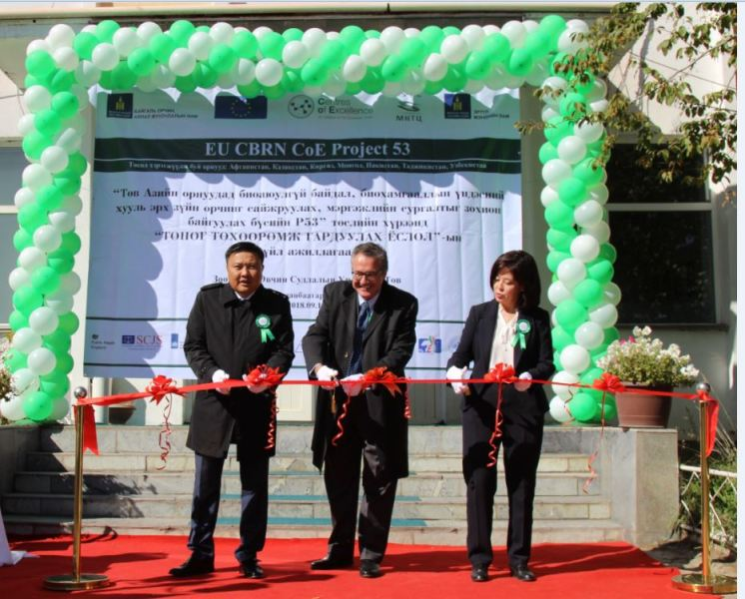
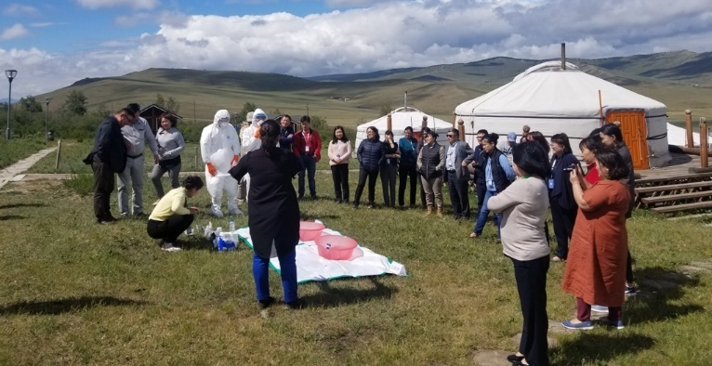
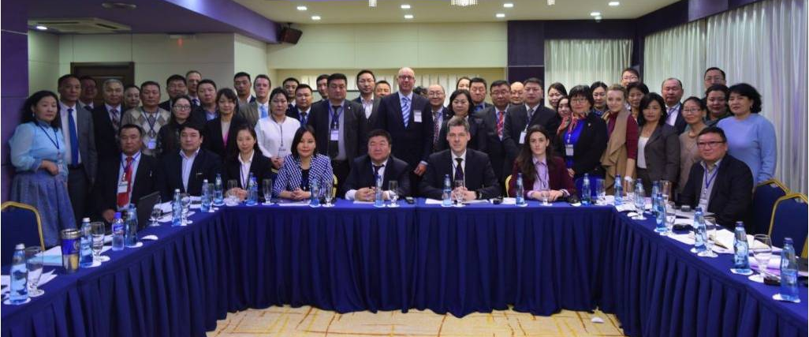
Legislative Recommendations
were formulated by the NTE and EU ToE on the harmonization of national legislation of the P53 Partner Countries to the Biological Weapons Convention (BWC), International Health Regulations (IHR) and Codex Alimentarius (Codex).

Laboratory Equipment and materials were provided to the Mongolia institutions within the framework of Project 53
336 experts and specialists trained in 11 workshops by the end of the project, including 4 Mongolian specialist that received international recognised certificates for Biosafety Cabinet Maintenance and Certification

Mongolia national Project 53 kick-off meeting 26-27 January 2017, Ulaanbaatar, Mongolia
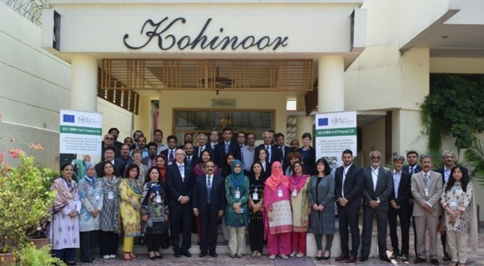
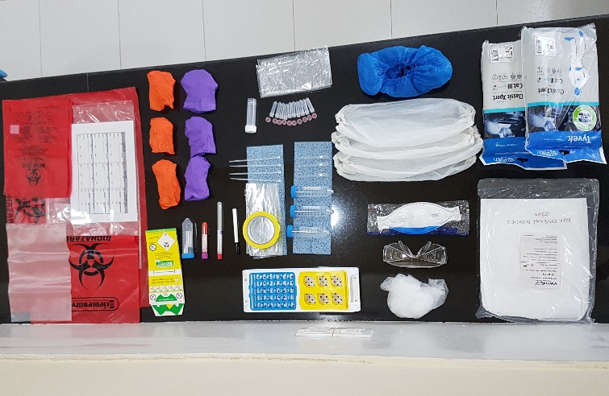
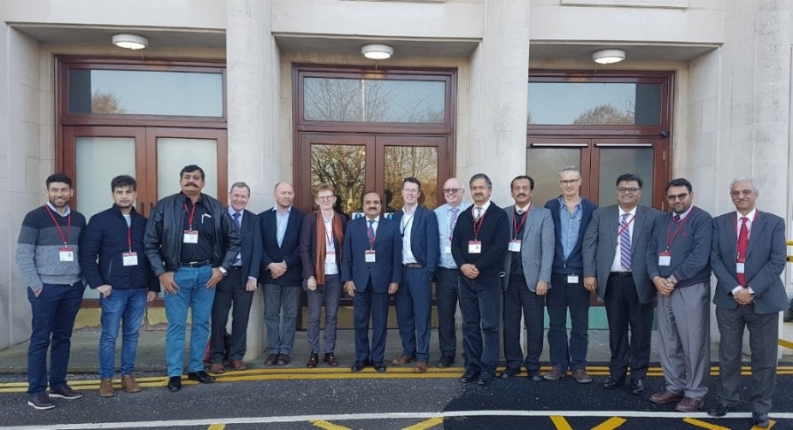
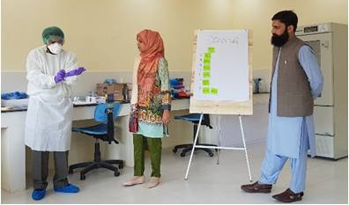
Project Highlights in Pakistan

Laboratory Equipment and materials were provided to the Pakistan institutions within the framework of Project 53
Study visit to Europe
A delegation of Pakistani health experts conducted Study Visit on the Public Health System in the UK 25-28 February 2019

More than 195 experts and specialists trained in more than 8 workshops by the end of the project

Pakistan national Project 53 kick-off meeting 9-10 April 2018, Islamabad, Pakistan

Train-the-Trainer workshop in Bio-safety/security was conducted for 14 trainers from Pakistan

Project Highlights in Tajikistan

Tajikistan national Project 53 kick-off meeting 28-29 September 2016, Dushanbe, Tajikistan
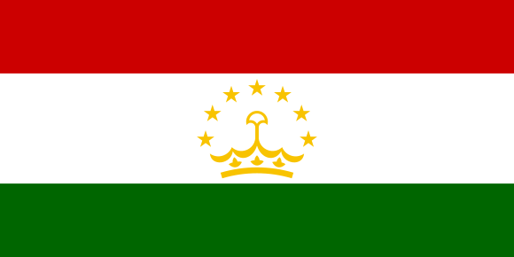

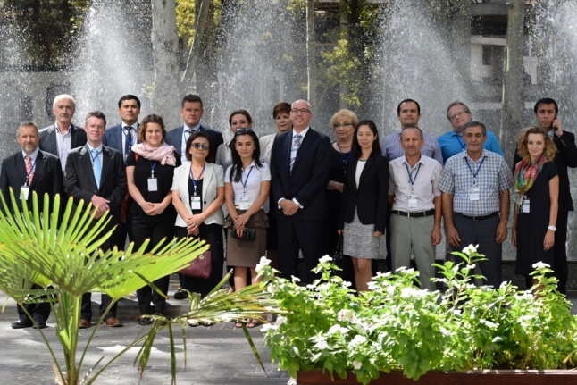
Train-the-Trainer workshop in Bio-safety/security was conducted for 14 trainers from Tajikistan

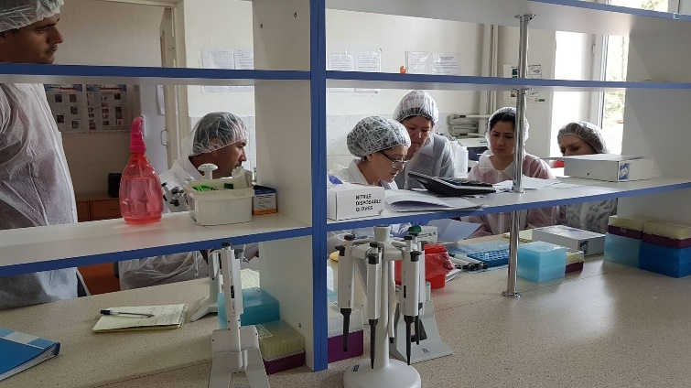

Laboratory Equipment and materials were provided to the Tajik institutions within the framework of Project 53

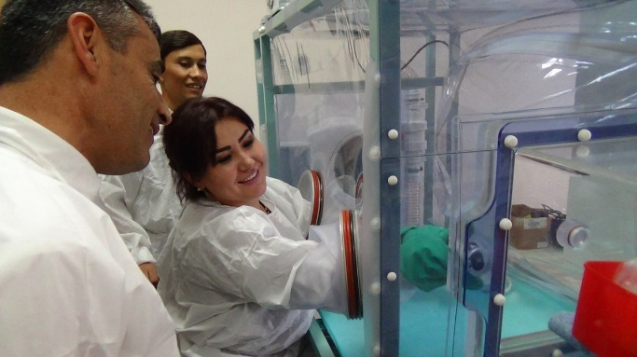
137 experts and specialists trained in 9 workshops by the end of the project, additionally training on molecular diagnostics workshops were provided to Afghan and Kyrgyz experts.

Legislative Recommendations
were formulated by the NTE and EU ToE on the harmonization of national legislation of the P53 Partner Countries to the Biological Weapons Convention (BWC), International Health Regulations (IHR) and Codex Alimentarius (Codex). Additionally, a draft Biosafety and Biosecurity Law was formulated, which currently is under review by the Tajik Government.

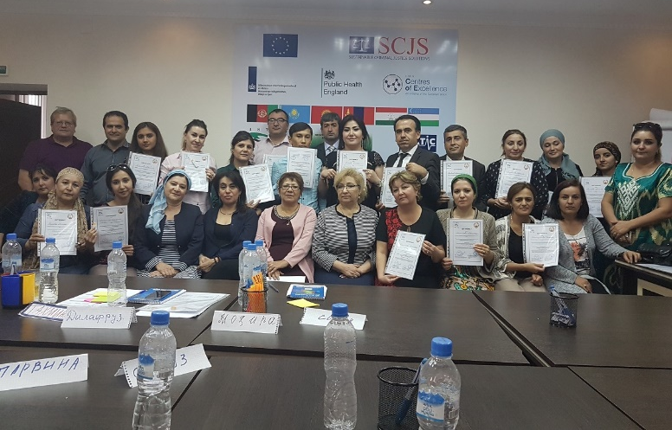

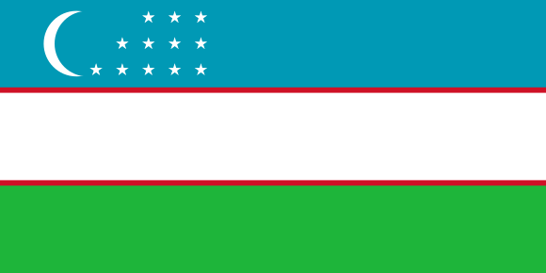
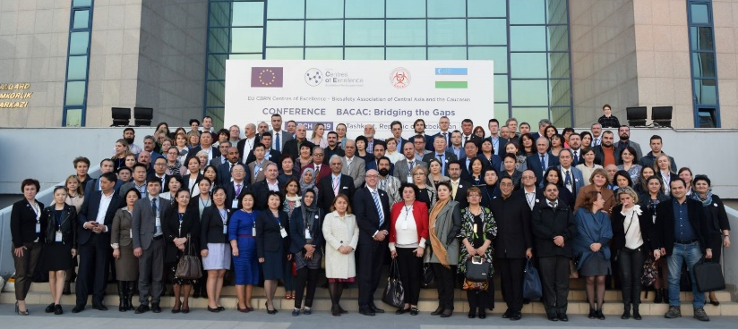
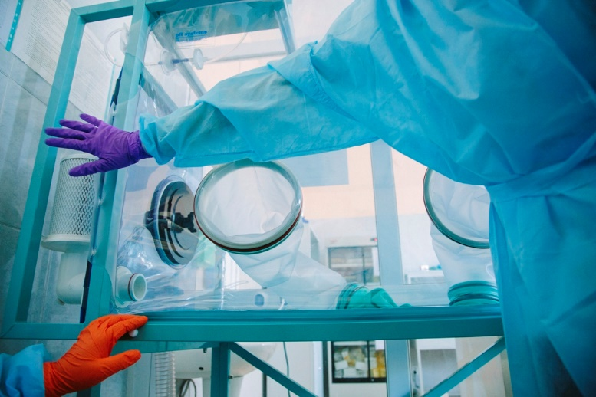
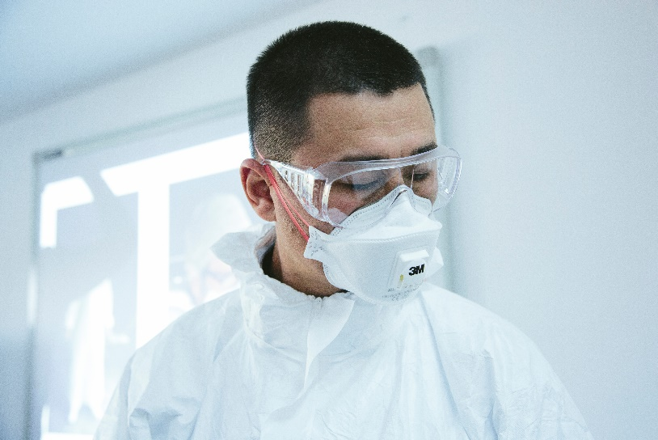
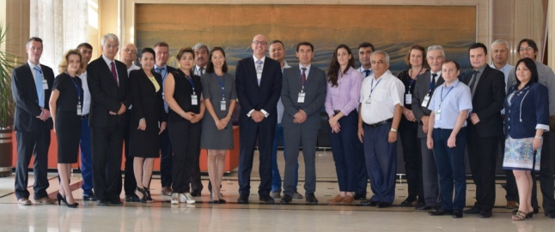
Project Highlights in Uzbekistan

Legislative Recommendations
were formulated by the NTE and EU ToE on the harmonization of national legislation of the P53 Partner Countries to the Biological Weapons Convention (BWC), International Health Regulations (IHR) and Codex Alimentarius (Codex)

Equipment for distance learning provided to the Uzbekistan within the framework of Project 53
The 2nd Reginal P53 Meeting and Regional CoE-BACAC Meeting conducted in Tashkent

Train-the-Trainer workshop in Bio-safety/security was conducted for 12 trainers from Uzbekistan

Uzbekistan national Project 53 kick-off meeting 22-23 September 2016, Tashkent, Uzbekistan
P53 Partner Countries’ Institutions

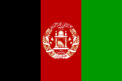  Afghanistan | Atomic Energy High Commission  National Public Health Institute (ANPHI/MoPH)  Ministry of Public Health (MoPH)  Ministry of Foreign Affairs
Republic of Kazakhstan | Infectious and Tropical Diseases faculty, Kazakh National Medical University  National Centre for Biotechnology – Ministry of Education and Science  Ministry of Education and Science  Ministry of Foreign Affairs  National Scientific Centre of Quarantine and Zoonotic Diseases
Kyrgyz Republic | Republican Centre of Veterinary Diagnostics  Ministry of Foreign Affairs  State Inspectorate for Veterinary and Phytosanitary  Republican Centre of Quarantine and Especially Dangerous Infections - Ministry of Public Health
Mongolia | Ministry of Environment and Tourism  National Biosafety Committee - Ministry of Environment and Tourism  Disaster Research Institute – National Emergency Management Agency
Islamic Republic of Pakistan | Field Epidemiology & Disease Surveillance Division – National Institute of Health  Public Health Laboratories Division – National Institute of Health  Ministry of Foreign Affairs
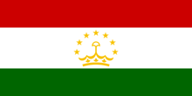  Republic of Tajikistan | Virology Laboratory - Institute of Preventive Medicine - Ministry of Health and Social Protection of Population  Institute of Biological Safety Problems - Academy of Agricultural Sciences  Licensing and Control of the Agency for Nuclear and Radiation Safety - Academy of Sciences  Virology Laboratory - Institute of Preventive Medicine - Ministry of Health and Social Protection of Population  Ministry of Foreign Affairs
Republic of Uzbekistan | SI "Sanoatgeokontehnazorat"  Centre for prevention of quarantine and especially dangerous infections - Ministry of Health  Tashkent Institute of Postgraduate Medical  National Coordinating Unit of the European Union's Technical Assistance Programme - Cabinet of Ministers of the Republic of Uzbekistan  Institute of Microbiology - Academy of Sciences  Ministry of Foreign Affairs

P53 Lead Implementer

International Science and Technology Center (ISTC), Kazakhstan (www.istc.int)
The ISTC, lead implementer of P53, has funded and managed several hundred projects in Central Asia over the past 20 years. The ISTC is an intergovernmental organization connecting scientists from Kazakhstan, Armenia, Tajikistan, Kyrgyzstan, and Georgia with their peers and research organizations in the EU, Japan, Republic of Korea, Norway and the United States.
ISTC facilitates international science projects and assists the global scientific and business community to source and engage with CIS and Georgian institutes that develop or possess an excellence of scientific know-how.

P53 EU Team of Implementers

Expertise to implement P53 is provided by a UK-led consortium of international legislative experts
(SCJS, VERTIC), and bio-safety and bio-security training experts (PHE, RIVM)

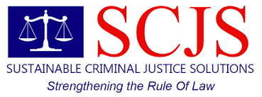 | Sustainable Criminal Justice Solutions (SCJS), United Kingdom  SCJS is a public sector operator, supporting and delivering criminal justice processes on behalf of and under the control of the UK Home Office and Ministry of Justice. SCJS seek to build sustainable partnerships at both national and international levels between public administrations with a particular focus upon the judiciary, court processes, prosecutors, police and other law enforcement bodies. In effect, delivering capacity building initiatives, including transnational and bilateral criminal justice projects on behalf of UK Government.
The Verification Research, Training and Information Centre (VERTIC), United Kingdom
VERTIC is an independent, non-profit making charitable organization, established in 1986 and based in London, United Kingdom. VERTIC supports the development, implementation and verification of international agreements as well as initiatives in relates areas. VERTIC provides this support through research and analysis, assistance and training, dissemination of information, and interaction with the governmental, diplomatic, technical, scientific and non-governmental communities. VERTIC’s work focuses on the development and application of monitoring, reporting, review, verification and compliance mechanisms, and on national implementation measures.

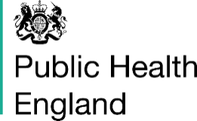 | Public Health England (PHE), United Kingdom  Public Health England (PHE) is an executive agency of the Department of Health established on 1 April 2013 to bring together public health specialists from more than 70 organisations into a single public health service. PHE is a distinct delivery organisation with operational autonomy to advise and support government, local authorities and the National Health Service (NHS) in a professionally independent manner.
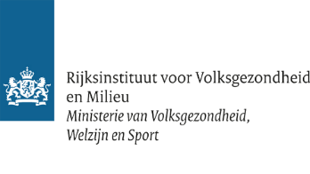 | The Rijksinstituut voor Volksgezondheid en Milieu (RIVM - National Institute for Public Health and the Environment), The Netherlands  RIVM, is a governmental research and knowledge institute providing policy support to the Dutch government. In 2011 RIVM employed approximately 1600 persons. RIVM performs tasks to promote both public health, and a healthy and safe living environment. The main tasks of RIVM are: 1) to conduct research; 2) to provide policy support; 3) to perform national coordination; 4) publish.

European Union Chemical Biological Radiological and Nuclear Risk Mitigation Centres of Excellence Initiative

The European Union Chemical Biological Radiological and Nuclear Risk Mitigation Centres of Excellence Initiative (or EU CBRN CoE) was launched in response to the need to strengthen the institutional capacity of countries outside the European Union to mitigate CBRN risks. These risks may be created intentionally (e.g. the Sarin attack on the Japanese subway), accidentally (e.g. Bhopal) or naturally (e.g. swine flu).
The Chemical, Biological, Radiological and Nuclear Risk Mitigation Centres of Excellence (CBRN CoE) is an EU initiative. It is led, financed and implemented by the European Commission, in close coordination with the European External Action Service (EEAS) and with the support of the UN (UNICRI) and other International Organisations and local experts.
A local worldwide network
The CoE aims to strengthen regional security by increasing local ownership, local expertise and long-term sustainability. The CoE is centred around a worldwide network of local experts and collaborating partners. In avoiding a traditional top-down approach, we work in partnership with countries to encourage local ownership of CBRN action plans, policies and project proposals. The CoE aims to strengthen regional security by increasing local ownership, local expertise and by ensuring long-term sustainability through this dynamic network that continues to evolve.
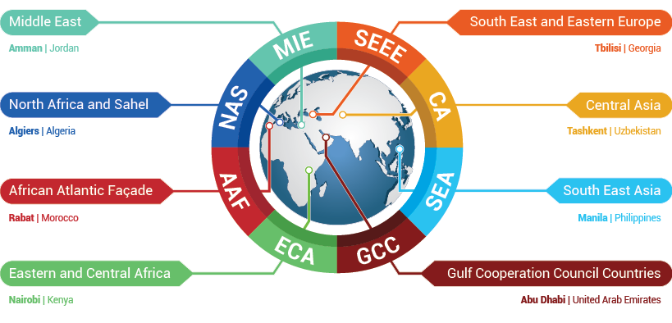
The countries that join the initiative work together in eight regions, headed up by a secretariat at regional level.

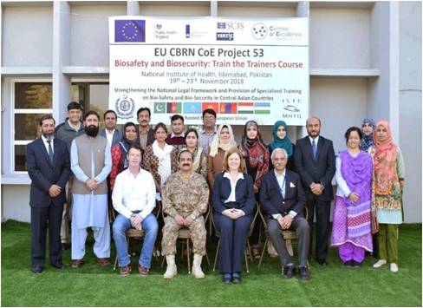
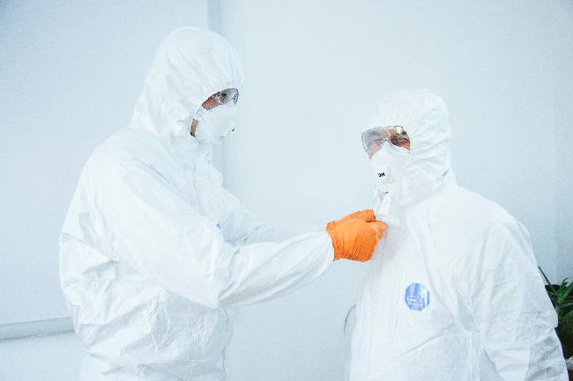
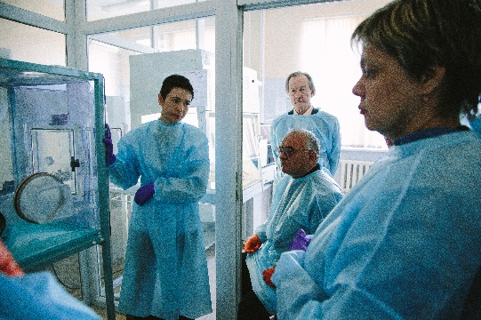
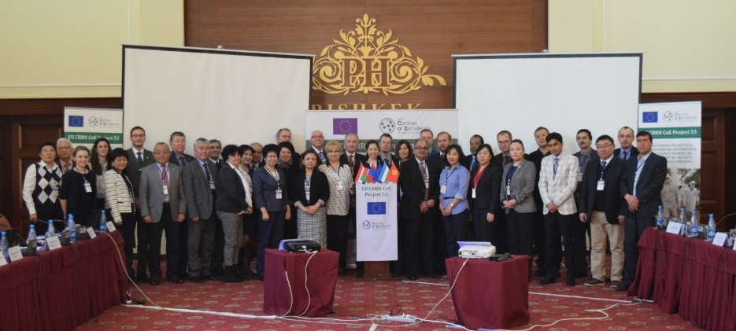
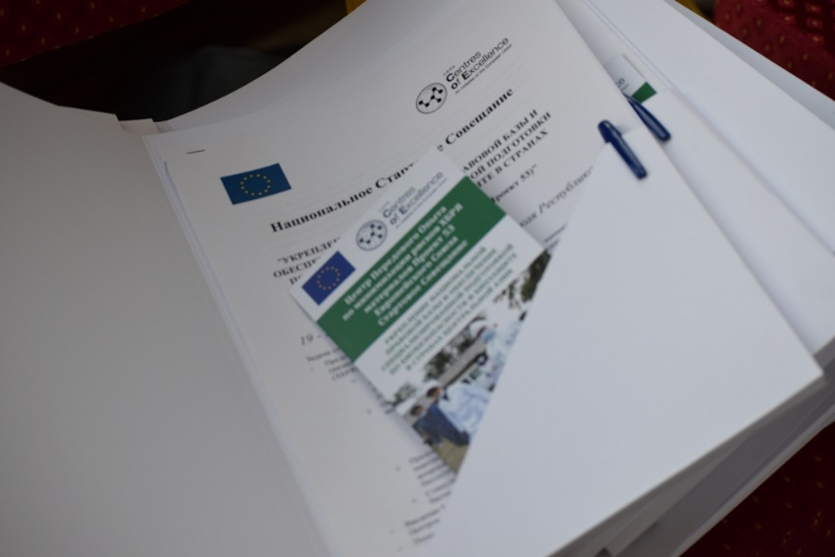
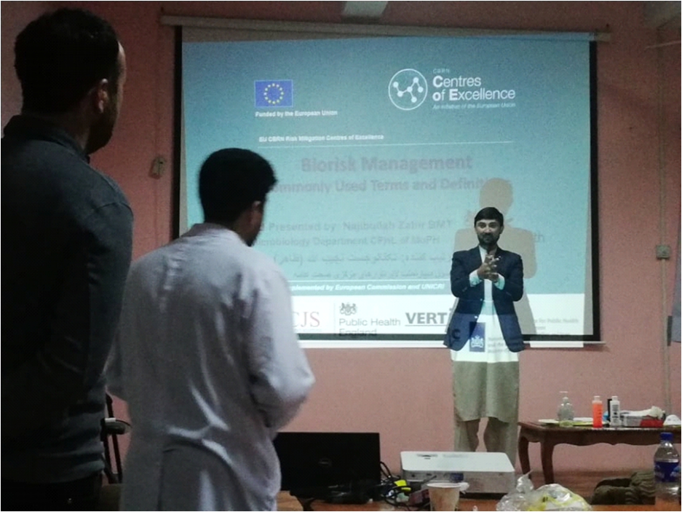
For more information about
EU CBRN CoE Project 53
please visit the dedicated website:

http://coe-project53.istc.int/

This publication was produced with the financial support of the European Union. Its contents are the sole responsibility of the International Science and Technology Center (ISTC) and do not necessarily reflect the views of the European Union. Despite every care taken, the author is grateful for any errors or omissions that are brought to its attention. The author also hereby disclaims any liability or responsibility arising from its use in any way.
© — 2019 — International Science and Technology Center (ISTC). All rights reserved. Licensed to the European Union under conditions.

