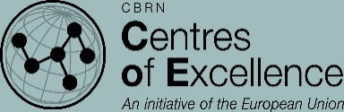
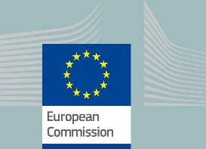
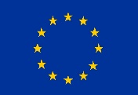

FACT SHEET

Project number:
P-60/378-227

Project duration:
36 months
(November 2016 - November 2019)

Budget:
€ 3,5 million

Source of funding:
European Commission,
Directorate-General for
International Cooperation and Development
(DG DEVCO),
Instrument contributing to Stability and Peace

Implementing agency:
International Science and
Technology Center, Astana
Executive Director:
David Cleave
(cleave@istc.int)

Project contact information:

DEVCO project manager:
Silvia Bottone, (Silvia.BOTTONE@ec.europa.eu)

ISTC project manager:
Kamen Velichkov, (velichkov@istc.int)

The implementation of this project is managed by EC DG DEVCO

PROJECT-60: SUPPORT TO THE CENTRE OF EXCELLENCE OF EASTERN AND CENTRAL AFRICA IN NUCLEAR SECURITY

Geographical scope
African countries, which belong to the EU CBRN Centre of Excellence (CoE) region of Eastern and Central Africa (ECA): Burundi, Democratic Republic of Congo, Ethiopia, Ghana, Kenya, Malawi, Rwanda, The Seychelles, Tanzania, Uganda, Zambia and Namibia.
Context
The countries of the ECA region face radiological and nuclear risks arising from uranium mining, milling, processing and transportation as well as from the state of management of radioactive sources. Past experiences (e.g. in Central Asia) show that sustainable uranium mining requires the application of best international practices and standards to avoid negative environmental impact and expensive remediation. Exporting uranium ore concentrate through several countries requires also harmonized legal frameworks and their synchronized implementation at border crossings to prevent illicit trafficking of radioactive materials. Project 60 seeks synergies with a parallel EU-funded project under the Instrument for Nuclear Safety Cooperation (INSC) - MC 5.01/15B “Support for Southern African Countries in Nuclear Safety and Safeguards”.
Main purpose
The overall long-term objective of the project is to strengthen and harmonize the nuclear regulatory frameworks in the participating countries, to enhance their nuclear safety and security and to support their efforts to fulfill the international safeguards obligations they have undertaken under the Nuclear Non-Proliferation Treaty; safeguards agreements with the IAEA; the Convention on the Physical Protection of Nuclear Material; the UN Security Council Resolution 1540; as well as the African Nuclear-Weapon-Free Zone Treaty. As part of the development policies in the ECA countries, radioactive sources are ever more widely used in medical institutions and in industry. The licensing, handling and control of these sources, especially at the end of their economic lifetime, occasionally results in leftover orphan sources. At the same time a more efficient regulatory oversight of licensed radiation sources acquires greater importance, as do the regular inspections on compliance.
Objectives:
•help upgrade and harmonize the national regulatory frameworks;
•bolster the accountancy and control of radioactive materials and sources, including through dedicated border control systems;
•define the needs for radiation detection equipment for enforcement and border management staff;
•support the detection, recovery and safe storage of orphan sources, as part of a national radioactive waste management policies, including through provision of training of personal and improvement of the standard operational procedures;
•help create or upgrade audited national inventories;
•assist in the development of national response plans (or additional components of existing emergency plans) for potential radiological or nuclear incidents, through the activities detailed below.
Activities
•a dedicated regional workshop on Radiological and Nuclear (RN) response plans;
•five Train-the-Trainer type courses in English language and two – in French language;
•seven field exercises in English language at sub-regional level at suitable locations, namely: two exercises for cross-border investigations of RN material; for illicit trafficking; for radiological crime scene management, respectively, and one – for uranium concentrated ore transportation; as well as three field exercises in French language – one in each category, except transport;
•seven simulation table-top exercises in English language at sub-regional level: two per the above-mentioned areas of cross-border incidents; illicit trafficking, and nuclear forensic investigation, and one – in uranium ore transportation as well as three table-top exercises in French language – one in each of the first three categories;
•on site expert visits and consultations as appropriate;
Public Advocacy
This project will contribute to raise public awareness in the participating countries through public events and media exposure, including through social media, TV discussions, a students’ debate on the peaceful use of nuclear power and presentations at specialized international exhibitions and fora.

